© Copyright [Year]

[Your full name as it appears on your Title Page]

*The doctoral dissertation full text is licensed under a* [*Creative Commons*](https://creativecommons.org/about/cclicenses/) *license*

*(default BY-NC-SA license).*

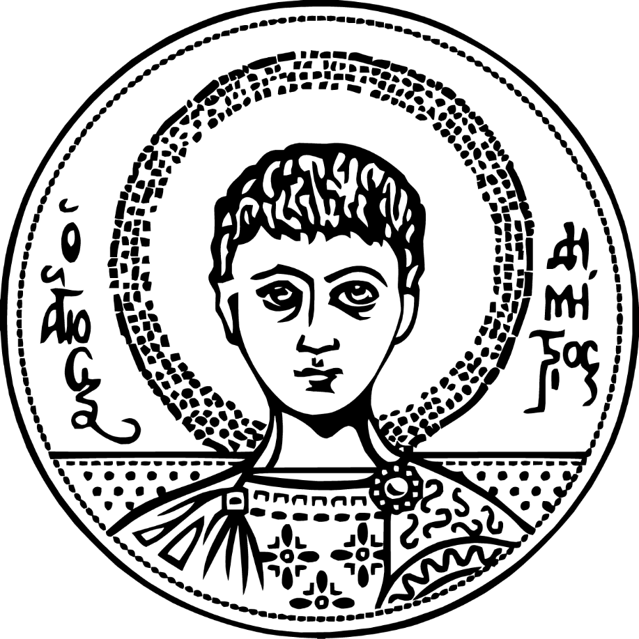

[Title of Your Dissertation]

[Your Full Name (first and last)]

A dissertation

submitted in partial fulfillment of the

requirements for the degree of

[Name of Degree (e.g., Doctor of Philosophy)]

Aristotle University of Thessaloniki

[Year (e.g., 2015)]

Reading Committee:

[Name of reading committee chair], Chair

[Name of reading committee member]

Name of reading committee member]

Program Authorized to Offer Degree: School of Physics

Aristotle University of Thessaloniki

Abstract

[Title of your Thesis/Dissertation]

[Your name as it appears in official AUTH records]

Chair of the Supervisory Committee:  
[Academic title and name of committee chair]  
[Chair’s Department]

[Please place the abstracts of the dissertation here. The abstract should be double-spaced and left-aligned. The abstract section does not go into the table of contents. An **English** and a Greek abstract in a single paragraph (no other paragraphs), up to 500 words each, typed in lowercase letters (except for sentence starters and proper nouns) and without mathematical formulas or polyphonic characters is needed.”]

[Please place the abstracts of the dissertation here. The abstract should be double-spaced and left-aligned. The abstract section does not go into the table of contents. An English and a **Greek** abstract in a single paragraph (no other paragraphs), up to 500 words each, typed in lowercase letters (except for sentence starters and proper nouns) and without mathematical formulas or polyphonic characters is needed.”]

TABLE OF CONTENTS

List of Figures iii

List of Tables iv

Chapter 1. Introduction 1

1.1 Cover Page 1

1.2 Table of Contents 1

1.3 Chapter Title and Heading Title Style 2

Chapter 2. STREAM Tools 3

2.1 Tables and Figures 3

2.2 Equations 4

2.3 Chapter Heading 5

2.3.1 Include Chapter Number in Figure Caption 6

2.3.2 Include Chapter Number in Equation Numbering 6

2.4 Section and Page Breaks 7

2.5 Subsections 7

2.5.1 Subsection Level 3 7

2.6 Orphan Control 7

Chapter 3. Complete Your Dissertation 9

3.1 References 9

3.2 Conclusions 10

Bibliography 11

Appendix A 12

You may use the chapter/section, and sub-chapter/section designation system of your choice. You may choose to use no numbers, Arabic numbers (1, 2, 3, etc.), Roman Numerals (I, II, III, etc.) or written numbers (One, Two, Three, etc.). You may choose to list some, all, or none of your subchapter titles in the Table of Contents. You may choose to number your sub-headings, or not to number them. Whatever formatting choices you make, you must carry them out consistently through each chapter/section of your document.

List of Figures

Figure 1.1. Increase in the cost of power quality problems in the Greece [1]. 2

List of Tables

Table 3.1. A Sample Table Caption 9

ACKNOWLEDGEMENTS

[The acknowledgement section goes here. The acknowledge section does not go into the table of contents.]

DEDICATION

[This page is optional and does not go into the Table of Contents]

# Introduction

This is a template document for dissertations, master’s theses or other long manuscripts, including books. This document is specific to one institution, but the vast majority of universities use very similar formats.

The paper guidelines from the University of Washington states that only 8 ½“ by 11” white paper can be used, and 11” x 17” may be used for fold-out pages. Smooth, flat-surfaced paper such as photocopy paper is preferred and only black and white text on white paper will be accepted.

Your thesis or dissertation must be written in English.

## Cover Page

The formatting of the cover page and first few pages needs to be followed exactly. There is no space to use creativity in this case. The degree name is strictly “Doctor of Philosophy”. In the committee page, make sure you have the exact template as in this dissertation. The chair person should be listed twice, in a separate section and in the committee list. The acknowledgements, abstract, and vita sections should not show up in table of contents.

## Table of Contents

The Table of Contents should be self-generated. The format of it can be changed through Insert-Index and Tables. The same is true for List of Figures. The List of Tables can be generated in the same command window as List of Figures.

Automatically, in the Table of Contents, the list and pages of “List of Figures,” “List of Tables,” and “Reference” won’t automatically generate. You can bookmark these titles at corresponding pages, and reference their page numbers in Table of Contents. In this way, you could auto generate the list in Table of Contents.

Do not forget to keep capitalization consistent in the Table of Contents. There should be at least two entries under each subheading (if you have 2.1, you must have 2.2). If you don’t, reconsider your headings and organization scheme.

## Chapter Title and Heading Title Style

Most universities have strict rules on the style of chapter titles and heading titles. The safest way is to follow this template and to consult with the appropriate parties who certify the formatting of a thesis or dissertation.



Figure 1.1. Increase in the cost of power quality problems in the Greece [1].

# STREAM Tools

This Microsoft Word file has been preset for compatible use with the STREAM Tools method for creating well-formatted reports and papers using the automatic formatting features of Microsoft Word. The principles behind the template are fully explained in [2] and [3] and at www.streamtoolsonline.org. The basic idea is to strive to achieve LaTeX-like functionality in Microsoft Word. This template is one of a set of templates. Depending on the document you are creating, you may switch to a template that meets your needs (e.g., single-column reports, books).

If you are highly confident in your mastery of Microsoft Word, feel free to use your own ways of numbering and positioning manuscript elements. Otherwise, by reusing examples of figures, tables, equations, and headings, you will save a lot of time and trouble writing and formatting manuscripts.

## Tables and Figures

It is convention to place captions below figures, yet above tables. To update the numbering of all automated entries (including the sequential numbering of figures and tables), press **CTRL-A** to select all text in the document, and then press **F9**. In this template we have added a heading style just for lists, which includes a list of figures, tables, and bibliography. We have assigned an entry in the Table of Contents, which will update automatically (Note: If you wish to add an Appendix you can use this style by clicking on the “Lists (for TOC)” style in the Home ribbon.)

All figures should be numbered in order that they appear in the document. This can be achieved by utilizing the automated code in this template. To add new figure to your document that utilizes this code, find a pre-existing figure and caption, highlight both the figure and the caption, copy both the highlighted figure and caption, and then paste the figure and caption to a location. Next, replace the caption text and figure image with your desired content. To update figure numbering, press **Ctrl + F9**. Remember that the letter and line thickness of each figure should be sufficiently large, in order to be clearly legible, even if placed into a double-column format. Otherwise, the text will be illegible when printed or when viewed in other formats. In order to create a new table, use the same command sequences as those for figures. However, to create a new table, use the existing table template (with the attached caption) instead. Cross-referencing a figure or table is also important to know.

Figure 1.1 is an example figure. To add an in-text reference to a figure or table, place the mouse pointer at the location where you wish to add the text reference. On the **Insert** menu, click **Reference** and then **Cross Reference**. In the **Cross Reference** dialog box, click the caption to which you are building the text reference. In the case of a figure, under **Reference Type** click **Figure** and under **Insert Reference To**, click **Only Label and Number**, then click **OK**. After that, select the inserted cross-reference and adjust its font size. This procedure is the same for tables. Also, make sure to select **Table** under Reference Type and not figure when cross-referencing a table. Otherwise, the process for cross-referencing tables is identical to that of figures. It is recommended to have indentation on both sides of a caption to distinguish the caption from normal text.

## Equations

Equations should be created using the template format below, using MathType, if it is available. MathType is superior to Word’s built-in equation editor, because it has more features, it is faster, and it allows for exporting to LaTeX. To add a new equation, find an existing equation in the document, copy the entire line of the equation, paste the equation where you would like it, and then replace the old equation with the new equation. The numbering and alignment of equation line elements are automatic. To update equation numbering, press **Ctrl + F9**. Note: this will only update the number to the right of the equation; to update numbering within the text you must create a cross reference.

To create an in-text cross reference to an equation, you must first create a bookmark for it. Highlight the equation number (which should be to the right of the equation). Next, go to **Insert**, **Bookmark**, and then create a name for your equation. All equation bookmarks should start with “eq” for identification purposes, such as eqEMC2. Then, click **Add** to create the bookmark. Next, go to **Insert**, **Cross reference**. In the dialogue box, select **Bookmark** and **Bookmark Text** from each dropdown list. **Uncheck** *Insert As Hyperlink*, then click **Okay**. This will make it such that whenever a new equation is added, the references to the equation will updated when **Ctrl + F9** is pressed. Pay attention to the font of your variables. It is not ok to have “*V*” in the equation and “V” in text. Auto-numbering of figures and tables that correspond to chapters (e.g. Fig 3.3) are discussed in the next section.

## Chapter Heading

First, you can define the style of headings of a chapter. Right-click on the line of the chapter’s title and choose “Bullets and Numbering,” push “Outline Numbered” tab, to choose different sample styles. You can also “Customize” the style like changing the “Number Format.” For example, you can add “Chapter” in front of the chapter number to make this the format of Heading 1*.

Next time, when writing a new chapter, just type in the chapter title, then choose “Heading 1”. Your defined style will automatically appear.

Another method of adding “Chapter” in front of each chapter number is to create “Chapter” character in other software, then copy it as a picture in front of the number.

If you make changes to the title format of one chapter, you can update all other chapters’ title format at the same time, instead of redoing them one by one. Just re-click “Heading 1,” a window of “Modify Style” pops up. Check “update the style to reflect recent changes.”

### Include Chapter Number in Figure Caption

To include the chapter number in a figure’s caption, click “Insert-Caption” and choose label “Figure.” Then click “Numbering,” check “include chapter number” and also choose a desired format. Thus, the chapter number will be included.

### Include Chapter Number in Equation Numbering

Normally only one number is assigned to one equation, as mentioned above. To include the chapter number, in front of the **original** equation number click “Insert-Cross reference-Heading-Heading number,” and then check the corresponding chapter. The chapter number will be present. Don’t forget to add a “.” between the chapter number and original equation number.

This is a sample equation [4]:

(2.)

Equation counting does not restart from 1 in a new chapter. To solve this problem, in a new chapter (For example in Chapter 2, please refer to beginning of next chapter), right-click before the **original** equation number, check “Toggle Field Codes,” the code will show up like “SEQ eq \* MERGEFORMAT,” add “2” after “eq” meaning the second (new) series of equation to “SEQ eq2 \* MERGEFORMAT,” then right-click “Toggle Field Codes” again, the second equation number in this new chapter will start from 1. For equations in the next chapter, just add “3” after “eq.”

Also, it is very important to define every variable of the equation in the text nearby. If you use a lot of equations, it pays to learn shortcuts in MathType.

## Section and Page Breaks

When writing a thesis, you are often required to use different styles of numbering for different sections. For example, Roman numerals are often used for preliminary pages, and Arabic numerals are used for text. You can achieve these differences by inserting section breaks: Insert-Break-Next Page (Section break types). After that, you can adjust the numbering style freely in each section. If you just want to start writing a new chapter from the next page in the same section (you want to continue the sequential numbering), you can just insert a Page Break.

## Subsections

Please use the following style for the sub-section heading titles.

### Subsection Level 3

This section is just to show you how to make sub-sections. Technically, since no subsection should exist by itself, there should be a following section 1.8.2. However, as this section is an example, a subsequent section is unnecessary. This style is Heading 3, and it will automatically show up in the table of contents, like the other headings.

## Orphan Control

Orphan control is very important in order to pass the review of graduate school. Make sure that no page ends with a heading title (any level), and make sure the figure title and figure are on the same page. The same concept applies for tables and table titles.

# Complete Your Dissertation

Some professors use *Ph.D. dissertation* and *Ph.D. thesis* interchangeably, while some other professors do not feel comfortable with the wording *Ph.D. thesis*. Use whichever term is preferred by your advisors.

This is a sample equation [4]:

 (3.)

where *t* represents time, *f* represents frequency, *η* represents continuous frequency shift, and *τ* represents continuous time lag. The ambiguity plane *A*(*η,τ*) for a given signal *s(t)* is defined as:

 (3. )

Here, *s*(*t*) represents the signal at time *t*, and *s*(*t*+*τ*) represents the signal at a future time *t*+*τ*, and the *s\**(*t*+*τ*) means the complex conjugate of *s*(*t*+*τ*).

is a sample table.

Table 3.1. A Sample Table Caption

|  |  |  |
| --- | --- | --- |
| Row 1 | Value | Location |
| Row 2 | 1.89 | Y |
| Row 3 | 1.94 | **N** |
| Row 4 | 2.33 | **N** |
| Row 5 | 1.45 | **N** |
| Row 6 | 2.11 | N |

## References

For literature citations, use EndNote software. The citations and references list should conform to the standards of your discipline.

It is very important to keep the consistency of the reference database file in the writing process, especially when you work on multiple computers.

## Conclusions

This template document will be updated as more and more students start to work on Ph.D. dissertations. Please do note that the requirements for MS thesis and Ph.D. dissertation are slightly different. Although this template may also be helpful for writing a MS thesis, it is important to identify the requirement difference and make appropriate changes.

For the Bibliography the easiest solution is to copy over the whole reference section. Programs are available to help with this, EndNote and Reference Manager, and there is also a References tool built into Microsoft Word.

Bibliography

1. B. Kennedy, *Power Quality Primer,* McGraw-Hill, 2000.
2. Mamishev, A., and Sargent, M. *Creating Research and Scientific Documents Using Microsoft Word*. Microsoft Press, 2014.
3. Mamishev, A., and Williams, S. *Technical Writing for Teams: The STREAM Tools Handbook*. IEEE Press; John Wiley & Sons, Piscataway, NJ; Hoboken, N.J., 2010.
4. L. Cohen, *Time-Frequency Analysis,* Prentice-Hall, 1995.

Appendix A

[Having an appendix is optional.]

VITA

[A short bio of the author is required for a Ph.D. dissertation at the Aristotle University of Thessaloniki. The vita section does not go into the Table of Contents. The formatting style follows the text of the dissertation.]